Reminder: At least two products each. Products decided and shared by Friday. Research done by Monday. Synthesizing Tuesday (10:00-12:00).

https://miro.com/app/board/o9J_lQQPwN4=/

# Overview

Direct Competitors: Vote 411, [Chicago Votes](https://chicagovotes.com/),

in-Direct Competitors: slidelizard, [chegg.com](https://www.chegg.com/press/college-election-tracker/), [FairVote](https://www.fairvote.org), [Do Something](https://www.dosomething.org/us)

**Competitive Analysis**

[Chegg.com](https://www.chegg.com/press/college-election-tracker/)

[FairVote](https://www.fairvote.org)

|  |  |  |
| --- | --- | --- |
|  | **Of some importance to users** | **Of high importance to users** |
| Things we do that they don’t | Infographic of based on Democratic and Democratic-leaning undergraduates nationwide  Ranked choice voting gives every voter a meaningful vote. | -Student Election Tracker surveyed  -released a report with the most important findings from the tracker and other student insights.  Check out our Activist Toolkit to advocate for better elections with ranked choice voting. |
| **Things we do better than them** | * Organized content to create better user flow * More simple/clear user interface/user experience research | - reforms that give voters greater choice, a stronger voice, and a representative democracy |
| **Things we do equally well** | Resourceful & Informative   * Focus on young students group | -RCV makes democracy more fair and functional.  voters interact with the ranked ballot |
| **Things they do better than us** | * report with the most important findings from the tracker and other student insights. * Interactive chart/graph | * local, state, and national level |

**Competitive Analysis:** [**Vote 411**](https://www.vote411.org/)

|  |  |  |  |
| --- | --- | --- | --- |
| Chris Bowling  03/25/2021  Company: Vote 411 | **Of some importance to users** | **Of moderate importance to users** | **Of high importance to users** |
| **Things we do that they don’t** | **Color Scheme-**  Colors can play a large role in how a service is perceived. We are aiming for a total nonpartisan approach. Don’t expect heavy Reds and Blues in our service. Instead harvest the energy found in orange, the highlights of a Turquoise, and the melding of parties through purple. Combined, these colors highlight the importance of unbiased information with a twist of youthful energy. Regardless we are breaking away from tradition and embracing  **Consistent Multi-Lingual System-**  The website offers external documents for languages other than Spanish and English, but the website, Vote 411, only has Spanish and English page translations.  **Dark Mode-**  Vote 411 sticks with a color scheme that can be considered Light Mode. Light Mode can be harsh on the eyes with a blaring white background. Lets mute the background and allow the content really stick out!Dark Mode is heavily utilized more than ever and there is a reason for it! (Majority of users are already using Dark Mode on other services, devices, and applications.) | **Retention Rate-**  We provide a system that documents user progression and retention of content. Our system is built for retaining information.  **Social Media-**  Our Social Media should be unique and driven by the same personality of the service we are creating. Create a community not only within the application but with an active community online. I would stray away from Canva animations as the templates are repetitive across industries. Be unique and bring the creative essence of the service within Social Media Platforms. | **Ease of Access-**  Due to gamification of the service users will be able to access categorized information, & tests. Using games as a way of building familiarity.  **Gamification-**  Our service is meant to educate yet it’s actually fun. Vote 411 has an abundance of information, but it’s not engaging. We intend to use our service to retain voter information and to improve the experience and betterment of new and continuing voters! |
| **Things we do better than them** | **Youth Engagement-**  Our Content is built on the idea that youth aren’t learning important voting information. Creating a service that is interactive and fun to use is something rare within this field. Youth Audiences want to feel included and through games we will help spark community action and engagement in which Vote 411 fails to do. | **Build for a**  **New Generation-**  Vote 411 is built for an older millennial audience. Our service tends to build familiarity and trust through being honest and straight to the point. Users are able to progress at their own rate and access this information through an application, website, and social-media. | **Be Unique-**  Though Vote 411 is a great resource for Voter Information it seems to lack personality. We intend on making the service interactive and visually pleasing for incoming youth voters. In today’s world users demand more visually pleasing, interactive, fun content. Thus, let's make voting fun! |
| **Things we do equally well** | **Resourceful**  **& Informative-**  A resource for educating people on the voting process.  **Geolocation-**  Vote 411 allows users to input their residence to see upcoming elections, voter information, and the ability to see if you are registered to vote! This helps build confidence and reassurance for people who are actively participating in local elections. Our service builds on the idea of relaying this information onto the user through gamification. Possibly work on adding a way for users to input locations to see if they are able to participate/ learn about local voting.  (Getting users comfortable with voting locally may improve voter turnout for General/ Presidential elections.)  **Web &**  **Mobile Friendly-**  Every Individual has interface preferences. Not only that but the need for multiple screen sizes and scalable applications creates a dynamic service. Lifting barriers of access for individuals with disabilities who use various interfaces to communicate and interact with others. Designing a system across different screen sizes and products allows universal/ equitable access to  our service. | **Accessible-**  Both systems provide multilingual options as every voter is unique.  The style of Vote 411 has been thoughtfully planned out. Utilizing contrasting colors for visually impaired users, has a solid organization Structure with interactive elements, and consistent page layouts to create a sense of content familiarity.  411 offers a Voter Checklist which is a great tool for users who want quick information right before voting! Our Service should provide Voting tips and tricks alongside the gamified system of voter information | **Here to Educate-**  A Non-Partisan platform that leaves any bias at the front door.  Providing important voter information to ease stress and access during the voting process. |
| **Things they do better than us** | **Vote 411 has Built**  **the Foundation for**  **Voter Information-**  They already list important information! No need to make a copy and paste of another service. Vote 411 acts as an informative archive and notice board for voter information. Offering access to state by state voter information, general election, and local election information. There is no need to make an account or sign up to obtain the information either! | **Provides External Resources and Partnerships-**  Vote 411 covers the questions people may have before and after the voting process. Some people may have Election Day problems in which they give linked phone numbers and organizations to reach out to on Voting Day with any questions one may have before entering the poll. | **Categorizes Information by Interactive Map-**  Vote 411 has Voting Information by State. This offers a catered experience to the service as it helps pinpoint vast information by State for ease of access.  Being able to Identify Information by State can be organized in many ways. Vote 411 Organizes the content in a more Visually Familiar image (the map of the United States). Thus, it makes finding this information a bit more interesting rather than running down a word list in alphabetical order. |
| **Things they do that we don’t** | **A Place to Check Voting Status and Polling Information-**  Offers Election Information like Registering to Vote and to verify that you are registered to vote in upcoming elections.  Vote 411 offers a Donation link! Vote 411’s prime mission is to provide critical voting information across all 50 States. This task will need all the help it will need thus Donations from the community to improve the system is always a nice added touch.  (Though the audience they are catering to may have disposable income vs. users who simply need a service to learn about the process!) | **Cross Networking-**    Connects service with Social Media. Social Networking is as important as the service itself. Engaging with youth audiences you must use social media. The mission to educate can still persist not only within the service itself but can live within a Social Platform that has existing users that constantly are consuming and engaging with content. | **Utilizes Local and State Sponsors-**  Vote 411 has State and Organization Partnerships. Partnerships build trust especially on a local level. Vote 411 has State Partnerships with Massachusetts and Mississippi. Look for possible Sponsors and Partnerships that may lead to success within those existing organizations and state needs for voter information services. |

**Competitive Analysis:** [**slidelizard**](https://slidelizard.com/en/classroom-polling-app)

|  |  |  |  |
| --- | --- | --- | --- |
| Chris Bowling  03/25/2021  Company: slidelizard | **Of some importance to users** | **Of moderate importance to users** | **Of high importance to users** |
| **Things we do that they don’t** | **General Market-**  We are not cornering ourselves within one environment. Being able to use personal devices rather it is accessed on a phone or a laptop. Accessibility is important for our platform and by allowing the usage of our service will help improve education within and outside classroom environments.  **Create Lasting Impact-**  We are not looking at making a quick buck.  Our platform is meant to help improve the  wellbeing of soon to be and current voters!  **More than**  **a Gimmick-**  We are not a plug-in. We are our own service. We strive to make change by addressing the problem at the root; by providing information in an engaging manner. | **Lives Outside the Classroom-**  Our service provides information outside of the classroom environment. Not everyone has access to such software and a community to practice and to participate within the voting process. Voting Services should not have paywalls! We intend on creating a platform for open discussion, important voting information, and all around fun interactive experiences. | **Highly Interactive Experience-**  Our service is a highly interactive game with natural progression based on the information Retention within the application!  Slidelizard is very linear. It’s not a game, rather a tool for learning the voting process. |
| **Things we do better than them** | **Interacting with Youth Outside the Classroom-**  Young Adults are constantly finding new ways to learn outside the classroom. This can be due to many factors, but for many, students seek information online. Students feel that school does not cover topics they are interested in or are not learning applicable skills and knowledge for building one’s future. Many students are disengaged the moment they enter those classroom doors. Let's make an environment that is comfortable for everyone! There shouldn’t be a learning curve or a plug-in to get our service running!  **Web &**  **Mobile Friendly-**  Slidelizard is limited. It lives within spaces where presentations occur. This limits this service to address interactivity within these specific environments. The service lives on larger interfaces like desktops and laptops with access to Microsoft Presentation. Allowing the usage cellular devices to interact with slides being presented to the User. | **Accessible-**  Our service is accessible in the sense that we are not an enterprise. Our service is meant for individuals not company marketing tools. The appeal and need for a service that is used outside of the classroom and workplace are important as there is no need to have industry professionals using the service. This service does not take in account the various devices and services individuals may need to use to interact with external applications. | **Engaging**  **Content for the Modern Era-**  For many of us classroom tools seemed a little out of touch. Modernizing and making the voting process a bit more cool than a Presentation Plug-in. Learning tools are constantly changing and a vast majority have access to a cell-phone or personal device that allows them to view our service. |
| **Things we do equally well** | **360 Marketing and Cross-Networking-**  The usage of QR codes to get new users on the platform can help incorporate users who aren’t in the ecosystem currently.  (Kind of like a food sample at a SuperMarket). | **Making Education Interactive-**  Provides a way of making the voting process engaging. When it’s not being used as a tool for learning it can help improve the overall wellbeing of voters across the U.S.  Both serve to keep users engaged with the content being presented in front of them! Sometimes presentations or the content that is being presented is deemed as “boring”. It's our job to find ways to improve this type of content and the visualization/ usage of the service. | **Hands On Approach-**  We both have goals in an educational standpoint.  Hands on education tools. Allowing the user to engage with the content presented. |
| **Things they do better than us** | **Making Dated Software a Little Relevant-**  Solution based platform for a specific job. Recording, storing, and conducting live voting through presentations. | **Great for Specific Business Eco-Systems-**  Implements the service within teleconference software as well. This we can see helps companies that utilize presentation to seamlessly present work. | **Class-Room Implementation-**  They have a market cornered. They have done their research and have found an engaging way to make powerpoints engaging |
| **Things they do that we don’t** | **It’s Okay to Use Your Phone in Class-**  Provides a solution for in class interaction, seamless powerpoint integrations, and seems to be more of a solution on how to keep people engaged during presentations.  **Trustworthy Product Plug-in-**  Slidelizard is a paid software. You are buying into a product that is constantly being updated and providing a trustworthy platform to store and use interactive elements in everyday presentations.  (Some people would rather pay for the software with the thought process that they are buying into a trustworthy product.) | **Built a System for Voting through Mobile Devices-**  Slidelizard’s purpose is to provide interactive, hands on experience with voting as a tool. Forming Familiarities through the actual voting process, analyzing data, and recording data. The application lives and thrive in classroom and higher education environments. | **Interaction in a Physical Environment-**  On the other hand slidelizard is a service being used within the classroom environment. Users are able to participate in the voting process, view results, store results, implement voting within presentations. |

[**Duolingo**](https://www.duolingo.com/)

**\*BTW* These are hypothetical wants/needs/perceptions of our platform, as nothing has been built yet.**

|  |  |
| --- | --- |
| **Georgia S** | **Notes** |
| **Things we do that they don’t** | **Civic Duty**  Duolingo pitches their service as a hobby, albeit a productive one. Voting, however, is a civic duty and part of our user indoctrination is to emphasize the importance of voting behaviors in the United States. |
| **Things we do better than them** |  |
| **Things we do equally well** |  |
| **Things they do better than us** | **Universal/Applied Skillset**  Learning a language is a highly individualized experience: Duolingo pairs users with the language of their choice as well as delivers a program that is up to par with the user’s difficulty level.  **While voting is largely a universal experience, gauging the user’s familiarity and individual circumstance is pertinent to the educational experience that we intend to deliver.**  **Big Mascot Energy**  Duolingo has steadily inspired our group throughout this semester. Specifically we are very into the ‘memeification’ of the mascot. The duolingo owl is super mean to its user and threatens to die. This went viral a few years ago and ultimately distinguished the platform from its |
| **Things they do that we don’t** |  |

[**Chicago Votes**](https://chicagovotes.com/about-us/)

|  |  |
| --- | --- |
| **Tim** | **Notes** |
| **Things we do that they don’t** | They do not have a mascot or any sort of interaction. Just a hub of information about getting involved at a young age in the Chicago land area. |
| **Things we do better than them** | Draw participants into our content via a more interactive interface. |
| **Things we do equally well** | Provide information for young people about getting involved with voting. Red and blue are used in their logos, but they are not overly dominant or connating politics. |
| **Things they do better than us** | Networking. Chicago Votes attempts to connect youths to political events and learning experiences going on around Chicago. |
| **Things they do that we don’t** | Connecting youths with activism opportunities other than voting. |

[**Do Something**](https://www.dosomething.org/us)

|  |  |
| --- | --- |
| **Tim** | **Notes** |
| **Things we do that they don’t** | We focus primarily on informing young participants about voting rights and the voting process, whereas these folks take a more encompassing view to being civically active. |
| **Things we do better than them** | We engage our audience by giving them something more interactive and personable. |
| **Things we do equally well** | Attempting to engage young people into civic activity. We both attempt to make participants feel like they are part of a bigger community. |
| **Things they do better than us** | Do Something focuses on different campaigns that range from getting young people to register to vote to volunteering to work with old folks. |
| **Things they do that we don’t** | This lot manages to offer scholarship opportunities as a reward for participating in their campaigns. They incentivize volunteering and taking action within their communities through scholarships and volunteer credits. |

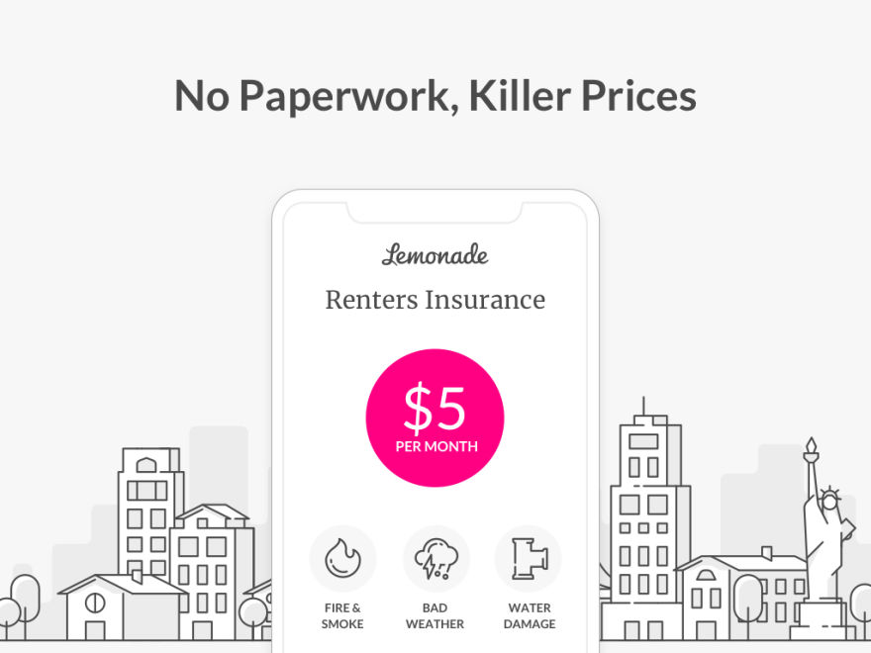

[**Lemonade**](https://www.lemonade.com/)

|  |  |
| --- | --- |
| **Georgia S** | **Notes** |
| **Things we do that they don’t** | **Civic Duty**  Duolingo pitches their service as a hobby, albeit a productive one. Voting, however, is a civic duty and part of our user indoctrination is to emphasize the importance of voting behaviors in the United States. |
| **Things we do better than them** |  |
| **Things we do equally well** |  |
| **Things they do better than us** | **Universal/Applied Skillset**  Learning a language is a highly individualized experience: Duolingo pairs users with the language of their choice as well as delivers |
| **Things they do that we don’t** |  |

|  |  |  |
| --- | --- | --- |
| Cassi Seifert  03/28/2021  Company: TurboTax | **What they do** | **What in their interface might do it** |
| **Things they do effectively**  **Things they do ineffectively** | **They have instilled trust with their customers.**  **Understandable content**  **Maintain Trust** | * **Formal fonts** * **Fluid User Experience** * **Minimalistic interface** * **Makes complicated** * **Confirmation of completion** * **Conversational Tone** * **Option to have a larger breakdown of each topic** * **Guided experience** * **Offering deals that are a scam** |

|  |  |  |
| --- | --- | --- |
| Cassi Seifert  03/28/2021  Company: TurboTax | **What they do** | **What in their interface might do it** |
| **Things they do effectively**  **Things they do ineffectively** | **They have instilled trust with their customers.**  **Understandable content**  **Maintain Trust** | * **Formal fonts** * **Fluid User Experience** * **Minimalistic interface** * **Makes complicated** * **Confirmation of completion** * **Conversational Tone** * **Option to have a larger breakdown of each topic** * **Guided experience** * **Offering deals that are a scam** |

[**Change.org**](https://www.change.org)

|  |  |
| --- | --- |
| **Rigoberto Cervantes** | **Notes** |
| **Things we do that they don’t** | They do not have a mascot but they do interact with many people all different ages. They are a hub that finds what’s important and takes action in vote and civil rights. |
| **Things we do better than them** | Draw participants into our content via a more interactive interface and add more notification on the importance of going around the US with education approach. |
| **Things we do equally well** | Provide information for all generation about getting involved with voting and the change needed in the US |
| **Things they do better than us** | They have a network of individuals around the US and focus on top that can connect toward youth and political events and certain votes toward rule of state or small town and high city.  Networking. Chicago Votes attempts to connect youths to political events and learning experiences going on around Chicago. |
| **Things they do that we don’t** | Connecting with all generation with activism opportunities other than voting. |